**Innovation Hub – Jan 2018 Circular – Term 2**

The Innovation Hub program run by Curiosity Gym in the second term will run for Grades 3,4, and 5 on Thursdays and for Grade 6,7,8,9 on Tuesdays from 3 pm to 4.10 pm.

Continuing students as well as new students are both welcome to the programme.

Since the activities at the Innovation Hub ECA expose students to different concepts of science, math, and technology there is no expectation that students have attended the previous term. On topics like 3D printing, that were covered in the first term, continuing students will be given more advanced exercises to design, and new students will be taught to do the design on CAD.

If you have missed registering in Dec 2017, and wish to register your child now for the sessions starting in January, 2018, please contact the MLSI ECA coordinator.

For the next semester we plan a mix of making and science and beginning electronics for Grades 3-5.

And for Grades 6-9, we will plan a comprehensive course covering electronics, DIY science and programming and jump on to a popular microcontroller – Arduino.

**Innovation Hub Term 1 Update – December 2017**

Innovation Hub classes run by Curiosity Gym started at MLSI in August’17.

The students’ have been very responsive and eager to learn. Each student has shown a spark and many times fire in the five pillars that we touch upon – Creativity, STEM (Science, Technology, Engineering, Math) concepts, Quick thinking, Innovation, Confidence and Leadership skills.

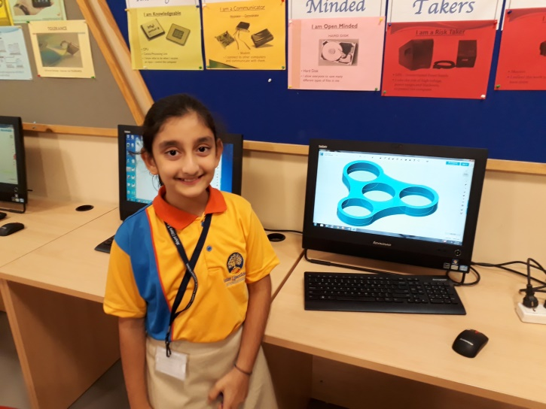Here is a brief update on the activities conducted at the class:

**For Grades 4-5:**

Students explored the new technology of 3D Doodling & 3D Printing. Designs were brought to life with 3D Doodling. They learnt various designing tools in a CAD software & 3D Printed dice, vases and fidget spinners. This activity taught them that any object they wish to make can be designed by them and made a reality.

We gave students a free hand in designing a game on basic arithmetic for younger students. This was how the Design Thinking paradigm was inculcated.

Students also touched upon Physics and Robotics through activities like:

* Making a Draw Bot: Making a gadget that with vibrating motors could make a doodle
* Thaumatrope: Students were exposed to the concept of ‘Persistence of Vision’ and how early animation was made
* DC Motor: Students learnt how to make a simple DC motor – how it works and the value of trial and error to get something working
* Vortex Cannon: We see vortices in cyclones, while swirling a bucket of water and at many other places. Students’ made a model to generate Vortices with smoke that can blow a stack of cups kept far away.

Students also were exposed to Math, Technology and Critical Thinking through the following activities:

* Binary magic cards trick: A concept that is used in computers and involves understanding binary Math concepts.
* Travelling Salesman: A Computer Science problem posed as a path reaching puzzle
* Cryptography: How to send secret messages. The messages can be read and can’t be understood. A Math and Computer Science problem which involves Critical Thinking.
* Modelling Machines: A treasure hunt games that helps us understand how vending machines, robots and elevators can be modelled.
* Fibonacci encoding: A Math trick to encode messages. Students can encode their names or date of birth and make a wrist band or a neck chain with beads denoting zeroes and ones
* Bubble Sort: A game enacted by students to understand how computers order a set of numbers.

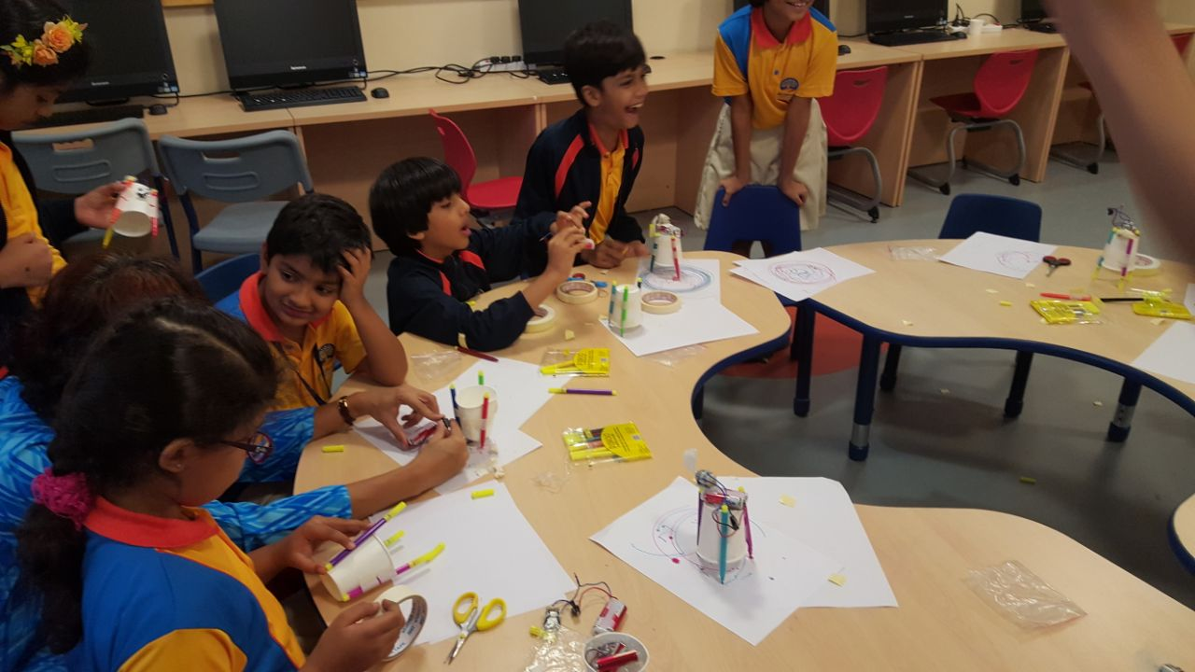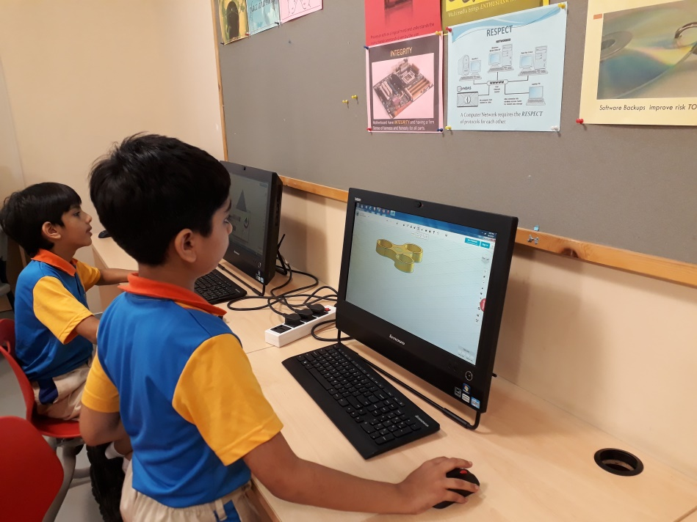

**For Grades 6-9:**

Students explored the new technology of 3D Doodling & 3D Printing. Designs

were brought to life with 3D Doodling. They learnt various designing tools in a CAD software & 3D Printed dice, vases and fidget spinners. This activity taught them that any object they wish to make can be designed by them and made a reality.

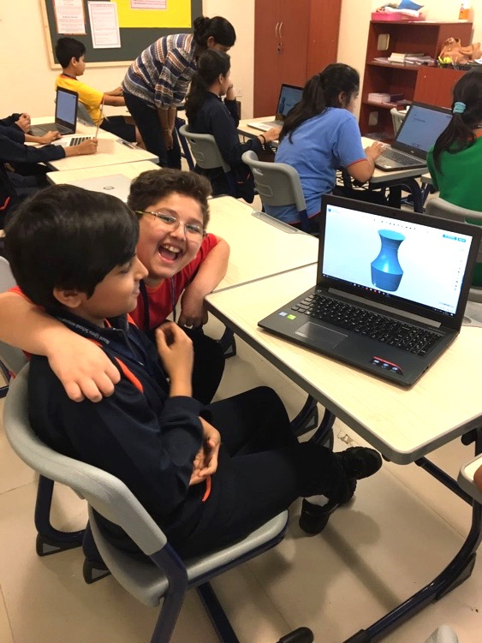We gave students a free hand in designing a game on basic arithmetic. These were there footsteps towards Design Thinking as a culture to inculcate.

Students touched upon Physics and Robotics through activities like:

* Making a Draw Bot: Making a gadget that with vibrating motors could make a doodle
* Magnetic Levitation: They made a floating pencil model with magnets to model the concept used in the Hyperloop and the maglev trains.
* Vortex Cannon: We see vortices in cyclones, while swirling a bucket of water and at many other places. Students’ made a model to generate rings with smoke that can blow a stack of cups kept far away.

Students touched upon Math, Technology and Critical Thinking through the following activities:

* Binary and Ternary magic cards tricks: A concept that is used in computers and involves Math and the aura around place value systems.
* Die Hard: A puzzle to crack and we discussed the algorithm behind to make it work and a math trick to detect unsolvable problems
* Crossword: An exercise to understand how crosswords are made
* Cryptography: How to send secret messages. The messages can be read and can’t be understood. A Math and Computer Science problem which involves Critical Thinking.
* 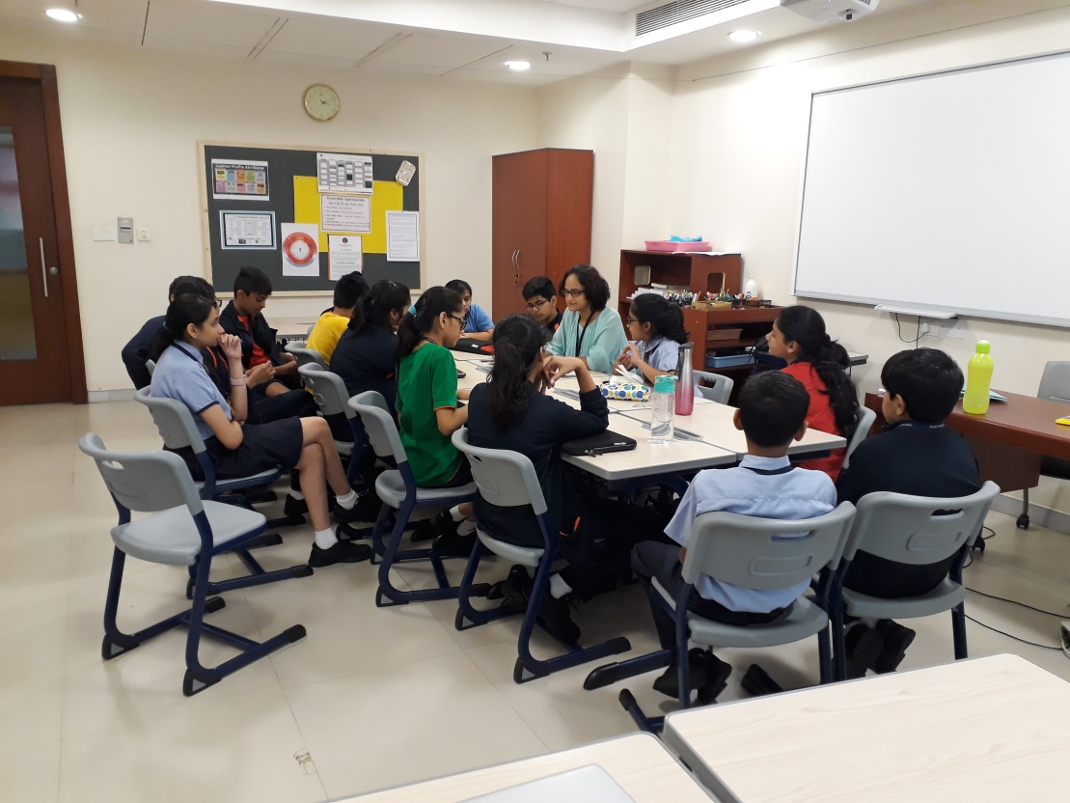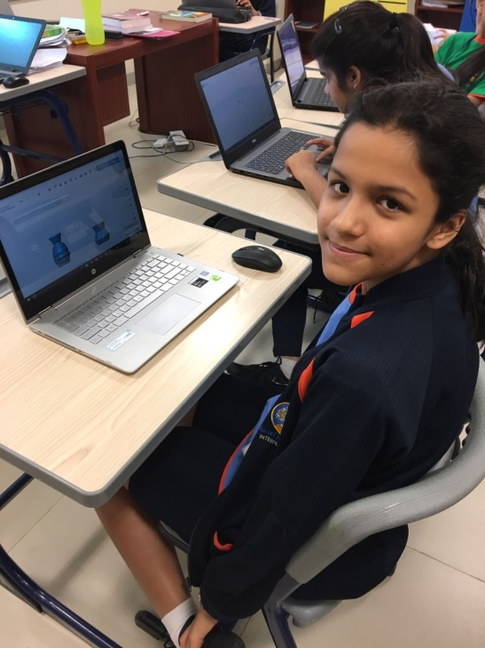Fibonacci encoding: A Math trick to encode messages. Students can encode their names or date of birth and make a wrist band or a neck chain with beads denoting zeroes and ones

Both the Tuesday and Thursday sessions had lots of fun passing on secret messages, dropping cups with smoke rings, performing math magic tricks, seeing their pencils float, play a treasure hunt game and so on.

Hope to see the students continue in the upcoming term.